**PROJECT REPORT**

**1.INTRODUCTION :**

**1.1** OVERVIEW :

First I created an EMPATHY MAP. A map has four quadrants -Says, Thinks, Does and Feels. How to improve our business in the market will be in say quadrent. Next I created BRAINSTROME . Our team take a problem statement and we discuss how to solve that problem. Our team problem statement is ” people has interested but they are not ready to buy “ . Then I created my data analysis – Dashboard and Story. Next step I published my Dashboard and Story in tableau public.

**1.2** Purpose :

Data analysis help a business optimize its performance, perform more efficiently, maximize profit, or make more strategically – guided decisions. The techniques and processes of data analytics have been automatic into mechanical processes and algorithms that work over raw data for human consumption.

**2. Problem Definition & Design Thinking :**

**2.1** Empathy Map :

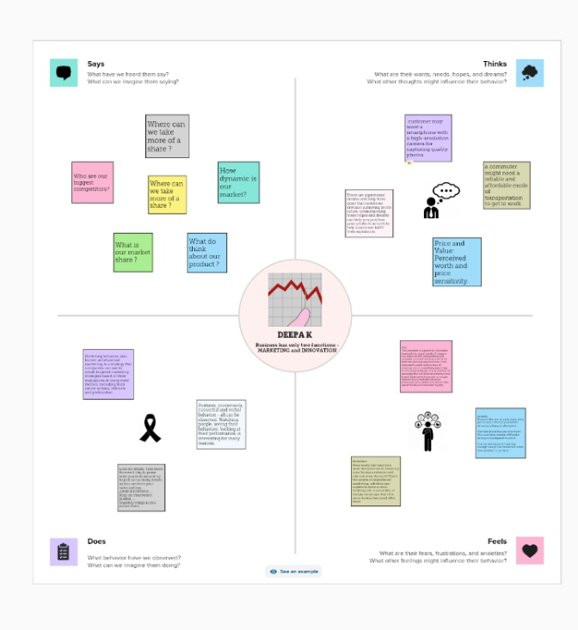

**2.2** Ideation & Brainstorming Map :

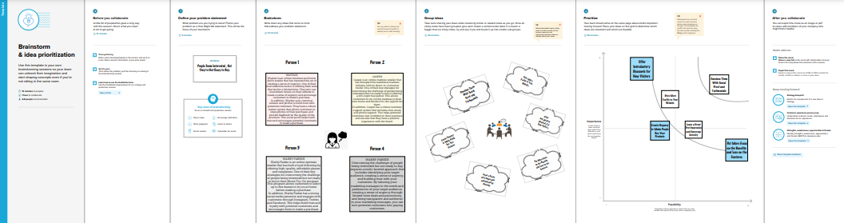

**3. RESULT :**

**DASHBOARD:**

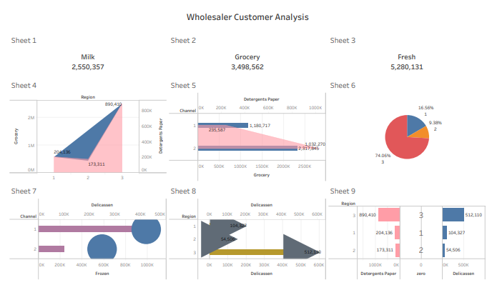

**STORY :**

**Milk KPI :-**

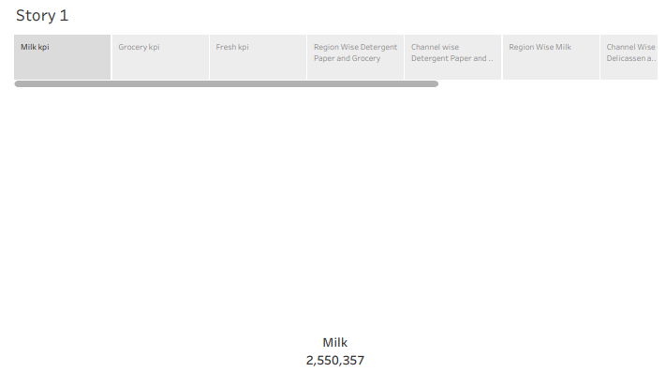

**Grocery KPI :-**

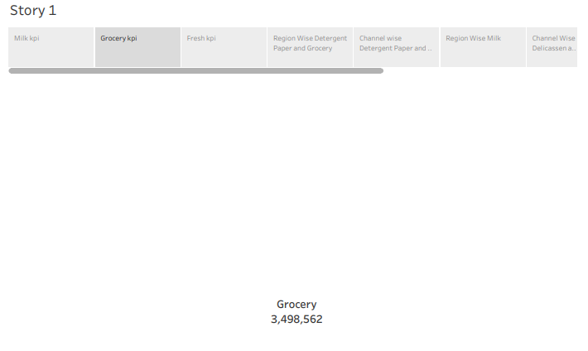

**Fresh KPI :-**

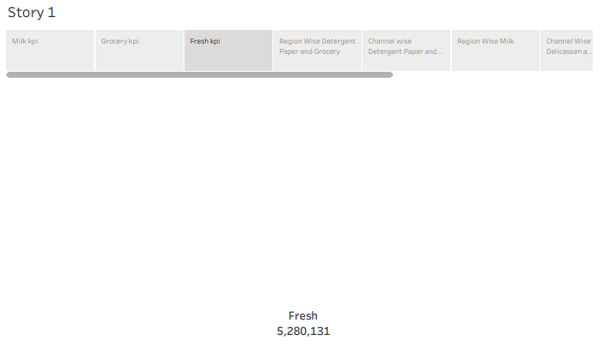

**Area and Polygon Region :-**

Grocery and Detergent paper for each Region. Color shows details about Grocery and Detergents paper. For pane sum of Detergents Paper. The marks are labled by Detergents Paper.

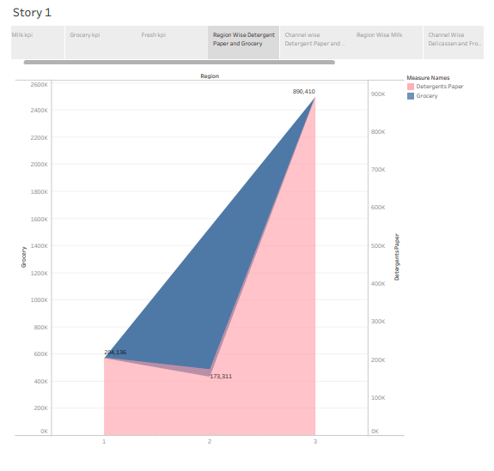

**Bar and Area :-**

Grocery and Detergent Paper for each channel. Color shows details about Grocery and Detergents Paper. For pane sum of Grocery and Detergents Paper. For pane sum of Grocery. The marks are labled by Grocery. For pane sum of Detergents paper. The marks are labled by Detergents paper.

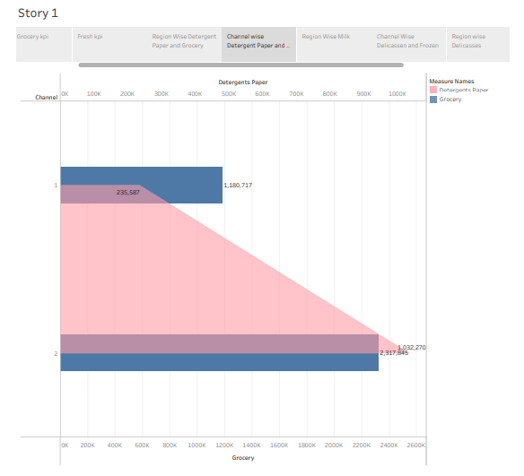

**Pie Chart :-**

% of Total Milk and Region. Color shows about Region. Size shows sum of Milk. The marks are labled by % of total Milk and Region.

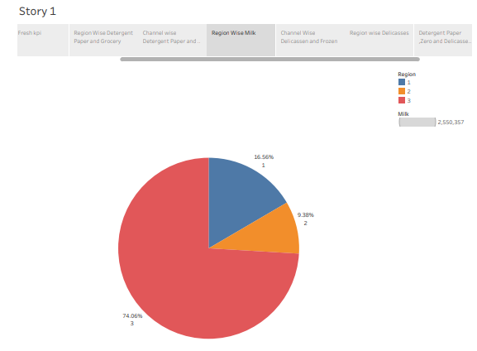

**Lolipop Chart :-**

Frozen and Delicassen for each Channel. Color shows details about Frozen and Delicassen.

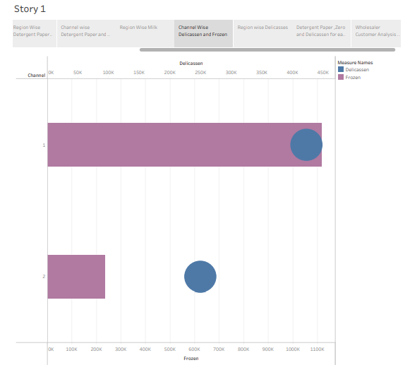

**Arrow Chart :-**

Sum of Delicassen and Sum of Delicassen for each Region. For pane sum of Delicassen. The marks are labled by sum of delicassen.

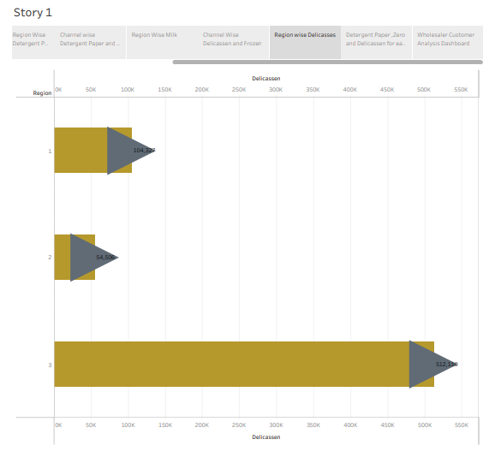

**Butterfly Chart :-**

Detergents papers, Zero and Delicassen for each region. Color shows details bout Detergents paper, Zero and Delicassen. For pane sum of detergent paper : The marks are labled by Detergent paper. For pane sum of Delicassen. The marks are labled by Delicassen.

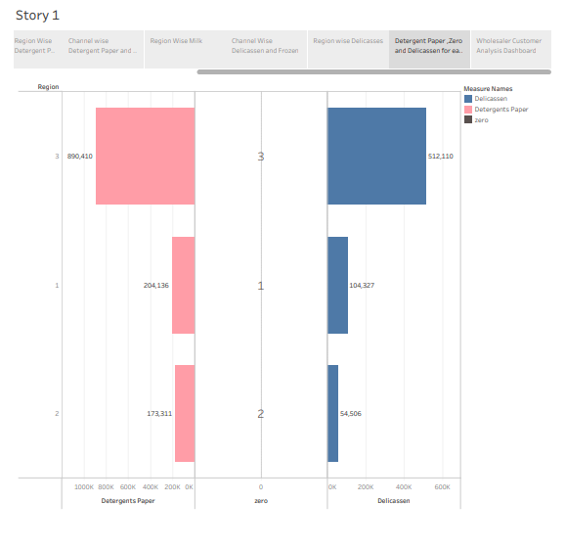

**Story Dashboard :-**

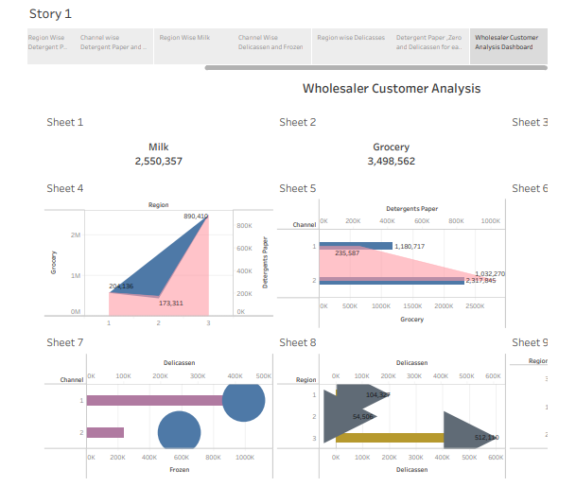

**4. ADVANTAGES & DISADVANTAGES :**

Advantage :

The main advantage of a market analysis is that it helps a firm save itself from potential loss. If a firm blindly introduces a product into the market without knowing who might buy it or why, then the product isn't likely to find success.

A market analysis reveals to the firm what it must change to meet the market's needs more profitably. It identifies how the firm can reach its potential consumers and appeal to their needs. Conducting a market analysis also helps firms identify when to discontinue products.

Disadvantages :

* Misidentifying Market Needs
* Evaluating Market Growth without market share
* Market segmentation versus target markets
* Improper interpretation of data

**5. APPLICATION :-**

### Building Better Customer Relationships

### **Appropriate Brand Positioning**

### **Optimizing Prices**

### **Designing Campaigns and Advertisements**

**6. CONCLUSION :-**

This is a clear enough fact that the more data a brand acquires the more avenues open for them to gain momentum in the market, to improve their services, to get better engagement from the customers, and also promote their brands and reach the right customers.

Strategy improvisation, looking for better alternatives and adequate channels for marketing is only possible with the basis of a strong conclusion provided by the big data. As the data gets interpreted notably helps in making better and informed decisions in a lot of industries and steps, big data having a remarkable application in marketing, is just yet another field.

**7. FUTURE SCOPE :-**

Market research plays a critical role in providing insights and data to businesses and organization that help them make informed decisions. As the global market continues to evolve and new technologies emerge , the future and scope of market research is constantly changing.